## **ReactJS Styling Questions**

Here are some ReactJS Interview Questions on Styling concept ReactJS.

### **9. How do you style React components?**

There are several ways in which we can style React components:

* **Inline Styling**

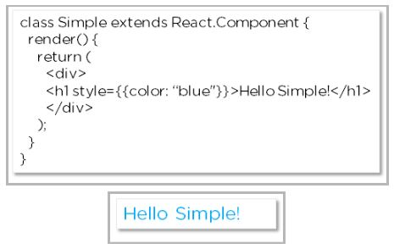

* **JavaScript Object**

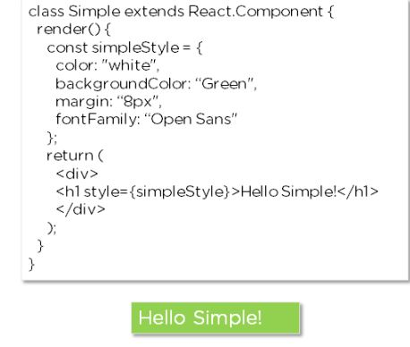

* **CSS Stylesheet**

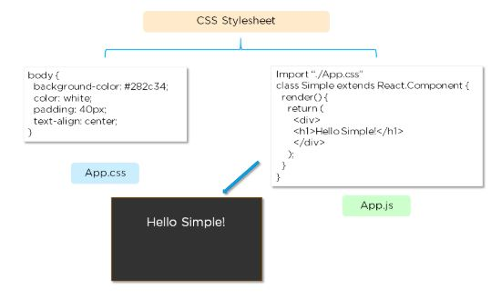

### **10. Explain the use of CSS modules in React.**

* The CSS module file is created with the **.module.css** extension
* The CSS inside a module file is available only for the component that imported it, so there are no naming conflicts while styling the components.

